**Year 1 - Pegasus Class Homework**

**25.6.24**

**Dear Parents/Carers**

***Home learning is now online!***

|  |  |
| --- | --- |
| **Homework Activity** | **Date completed and parent’s signature** |
| **Reading:**  Children should be reading for 15 minutes each day. | **Please sign in the reading diary.** |
| **Spelling:**  LOOK, SAY, COPY, COVER, WRITE, CHECK spelling tricky word sheet | **Please check this is correct in your child’s book.** |
| **English:** Can you draw your own creature to add to your fantasy story? Write the creature’s name? Write what special ability he/she has. | **Parents to check, teacher will also check.** |
| **Maths:** Mathletics online  **Maths 2:** Can you practice writing the days of the weeks and months in the year, we will be practicing and learning about time next week. | **Parents to check if it completed online.**  **Teacher will mark in books.** |

|  |  |  |  |  |  |
| --- | --- | --- | --- | --- | --- |
|  |  |  |  |  | |
| **Look and Say** | **Copy into your book** | **Cover and write** | **Write it again** | **Check it** | |
|  | **Words to be spelled** |  |  |  |  |
| 1 | because |  |  |  |  |
| 2 | climb |  |  |  |  |
| 3 | only |  |  |  |  |
| 4 | improve |  |  |  |  |
| 5 | feather |  |  |  |  |

**Can you think of and write a sentence using three words? Write them into your books.**

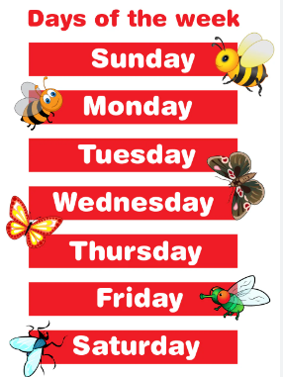

**Please practice spelling and writing the order of the days of the week and months of the year. Children should practice what comes before and after a given day or month.**

